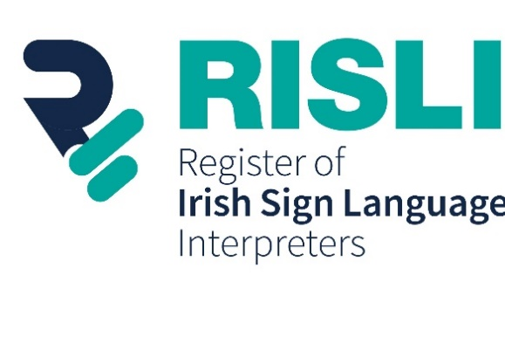

Registration Application Form

Personal Information will be required to process your application. All information will be held in accordance with GDPR. Information shared on risli.ie will include the interpreter’s full name and their qualification(s)/accreditation(s).

1) Personal Details:

Name  Your name will be displayed on the RISLI Website |  | Title (Mr / Mrs / Ms / other)
Address
Date of Birth
Mobile Number
 | Text Only? Yes ____ No ____
E-mail Address
Photograph
(Please upload a photo for your ID card)
Identification | Please upload a photo that we can use to verify your identification. Acceptable forms of photo ID include a passport, driver’s licence and public services card.

2) Qualifications:
Please tick the qualification route that applies to this application and the year in which you achieved this qualification. Also, please attach or enclose proof of your qualification/accreditation for each one that applies to you.

Route |  |  |  |  |  |  | ✔ | Year
Bachelor’s Degree in Deaf Studies (Interpreting), Centre for Deaf Studies, Trinity College Dublin (NFQ Level 8)
Diploma in Sign Language Interpreting with Level 6 NVQ Certificate in Irish Sign Language, Signature (equivalent to NFQ Level 8)

Diploma in ISL/English Interpreting, Trinity College Dublin (NFQ Level 7)

Diploma in Deaf Studies (ISL/English Interpreting), University of Bristol (equivalent to NFQ Level 7)

Masters in Interpreting Studies (with Irish Sign Language / English language pair), Queens University Belfast (equivalent to NFQ Level 9)

Accreditation processes (NRB / SLIS / Irish Sign Link) |  | RTI | RQI | R1 | RD1 | R2 | RD2
Other | Name:  (If you qualified through another route please specify. Please attach or enclose as much detail as possible, including the institution that delivered the qualification, course content, and contact details for organisers

Please indicate below if you are having difficulty providing proof of your qualification/accreditation

4) Consent:

Please tick if you wish the following information to be shared on the RISLI website (Optional) | ✔
Mobile Number
Email
Photo

RISLI Consent Form:
Please tick the relevant boxes below, sign and date

□ I hereby consent to have my name and my qualifications published on the RISLI Website.

□ I confirm that I intend to carry out the required level of interpreting work practice (voluntary or paid) per year, and to submit evidence of this work practice should I be selected for a Work Practice Audit.

□ I confirm that I intend to fulfil all the Continuing Professional Development (‘CPD’) requirements and to submit evidence of this should I be selected for a CPD Audit.

□ I hereby agree to abide by the RISLI Code of Conduct.

□ I hereby agree to undergo Garda Vetting if requested by RISLI.

□ I confirm that I am aware of and hereby agreed to abide by the Complaints and Mediation Process, and to adhere to any decision made by the Complaints Sub-Committee or Appeals Committee against me as a result of a complaint to RISLI via the Complaints and Mediation Process.

Fit & Proper Form:
Please circle YES / No to the following questions and sign and date this form if the answers to these questions are accurate:

- Have you ever been convicted of a criminal offence in the State or elsewhere, or are there any criminal charges pending against you in the State or elsewhere? Yes / No

[Please note that under the Criminal Justice (Spent Convictions and Certain Disclosures) Act, 2016, certain convictions which are "spent" do not need to be disclosed. You should take legal advice if you have a conviction and are unsure whether it is spent]
If yes, please give details:

- Do you have any serious physical health or mental health illness or condition that may affect your ability to carry out interpreting duties? Yes / No
If yes, please give details:

- Is there any other relevant information that RISLI should know about which may have a bearing on your suitability to register? Yes / No
If yes, please give details:
Data Protection Consent Form:
Please tick the boxes below and sign and date this form if you agree
□ In accordance with the Data Protection Acts 1988-2018 and the General Data Protection Regulation (GDPR) (EU 2016/679), I freely give my specific, informed and unambiguous consent to RISLI and Sign Language Interpreting Service (SLIS) (as joint data controllers) to process my personal data to:

  - Confirm that the registrant meets minimum criteria for initial membership of the Register
  - Record the starting date of registration
  - Record registrant details on the online Register Directory
  - Record your registration status
  - Provide a photo ID card to registrant
  - Provide information, support and advice to registrants
  - Provide information regarding upcoming CPD opportunities to registrants
  - Send emails and newsletters regarding the Register’s work
  - Confirm that the registrant meets minimum requirements in relation to CPD and Work Practice
  - Consider and investigate any complaints or appeals brought against a registrant
  - Confirm that the registrant meets minimum criteria for membership of any Specialisation Panel
  - Record registrants’ membership (if any) of a Specialisation Panel
  - Record evidence of termination of registration
  - As otherwise stated in the privacy policy
  - As otherwise required or permitted by law or where those involved with the Register have a legitimate interest in processing my data

□ I understand that the joint data controllers retain the right to verify any and all documentation /evidence submitted as part of your application or for the maintenance of your registration.

□ I understand that at any time I can withdraw my consent to the processing of my personal information. I understand this may lead to the removal of name from the Register.

□ I have read, understand and agree with the terms of the GDPR and Privacy Policy, and accept that RISLI and SLIS (as joint data controllers) have a legitimate interest in processing my personal data in accordance with the Privacy Policy.

Declaration:
□ I hereby declare that all the information given by me in this application form is accurate, to the best of my knowledge.

Signature:
Date:

If you require any assistance in completing this form you may contact admin@risli.ie

Thank you for completing the form and uploading the requested qualifications and documentation.
Your data is stored in accordance with GDPR legislation and you can opt to have your information shared on the RISLI website by signing the form with your digital email.
Correspondence will be shared using only the email and phone number you have provided in this form.

Sign Language Interpreting Service / Irish Sign Link Accreditation processes (1997, 2000, 2006, 2009. Please see National Register – Background Briefing. This was also dealt with in Leeson & Venturi (2017) p. 21-23.
For more information, see section 2.1 Registration Process (Non-Recognised Qualification)

