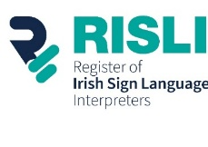
Expression of Interest Application Form
RISLI Registration Sub-Committee Member

Expression of Interest Application Form for membership of the Registration Sub-Committee of the Register of Irish Sign Language Interpreters (RISLI). The application form can be submitted in Irish Sign Language (ISL) or written English.

Applicant Details

Name
Address
Mobile
Email Address

Experience
Please provide information about your knowledge and professional experience that may be relevant to this role.

Previous Committee Experience
Please provide relevant information on your involvement on Committees, Boards and/or other organisations.

Referees
Please provide contact details of at least two referees RISLI can contact in relation to your applicant. We will notify you first, before contacting the referees.

Name | Email Address | Phone number

Please submit the Expression of Interest Application Form in ISL/Written English by email to manager@risli.ie
If you wish, you may also submit additional information (such as a C.V. or short Bio) to support your application.

Signed |  | Date

